NAAC A++
Ph.: 07104-237919, 234623, 329249, 329250 Fax: 07104-232376, Website: www.ycce.edu

Department of Computer Technology
Vision Statement of the Department.
To be a preferred hub for nurturing computer engineering aspirants through innovative, ethical, value-based technical education, impactful research, and industry collaboration, to become successful professionals contributing for the betterment of society.
Mission Statement of the Department.
To nurture computer engineering professionals by offering Dynamic learning environment that encourages problem-solving using emerging technology, National Education Policy aligned evidence-based technical education, fostering ,innovation, research, and industry–institute collaboration & Holistic, ethical and sustainable development for lifelong success.

Session 2026-2027

Vision:Dream of where you want. | Mission: Means to achieve Vision

Program Educational Objectives of the program (PEO): (broad statements that describe the professional and career accomplishments)
PEO1 | Preparation | P: Preparation | Pep-CL abbreviation
PEO2 | Core Competence | E: Environment (Learning Environment) | pronounce as Pep-si-lL easy to recall
PEO3 | Breadth | P: Professionalism | pronounce as Pep-si-lL easy to recall
PEO4 | Professionalism | C: Core Competence | pronounce as Pep-si-lL easy to recall
PEO5 | Learning Environment | L: Breadth (Learning in diverse areas) | pronounce as Pep-si-lL easy to recall

Program Outcomes (PO): (statements that describe what a student should be able to do and know by the end of a program)
Keywords of POs:
Engineering knowledge,Problem analysis, Design/development of solutions,Conduct Investigations of Complex Problems, Engineering Tool Usage, The Engineer and The World,Ethics, Individual and Collaborative Team work,Communication, Project Management and Finance, Life-Long Learning

PSO Keywords: Cutting edge technologies, Research

“I am an engineer, and I know how to apply engineering knowledge to investigate, analyse and design solutions to complex problems using tools for entire world following all ethics in a collaborative way with proper management skills throughout my life.” to contribute to the development of cutting-edge technologies and Research.

Integrity: I will adhere to the Laboratory Code of Conduct and ethics in its entirety.

Name and Signature of Student and Date
(Signature and Date in Handwritten)

NAAC A++
Ph.: 07104-237919, 234623, 329249, 329250 Fax: 07104-232376, Website: www.ycce.edu

Department of Computer Technology
Vision Statement of the Department.

To be a preferred hub for nurturing computer engineering aspirants through innovative, ethical, value-based technical education, impactful research, and industry collaboration, to become successful professionals contributing for the betterment of society.
Mission Statement of the Department.
To nurture computer engineering professionals by offering Dynamic learning environment that encourages problem-solving using emerging technology, National Education Policy aligned evidence-based technical education, fostering ,innovation, research, and industry–institute collaboration & Holistic, ethical and sustainable development for lifelong success.

Session | 2024-25 (ODD) | Course Name | Web Technology Lab
Semester | 3 | Course Code | 23CT1301
Roll No | 32 | Name of Student | Arati Lod

Practical Number | 5
Course Outcome | - Understand various internet technologies.  - Design the web pages using HTML and CSS.  - Implement the XML technology to store the data.  - Develop the interactive web pages using JavaScript.
Aim | JavaScript — Events &amp; Interactivity  Sample Problem Statement: Build ONE interactive app — a Calculator OR a short Quiz (pick  one) — that responds to clicks/key-presses and updates results dynamically, demonstrating  event handling.
Problem Definition | Develop an interactive Calculator web application using HTML, CSS, and vanilla JavaScript. The calculator should respond to button clicks and keyboard inputs, perform basic arithmetic operations, and dynamically display results. The main objective is to demonstrate JavaScript event handling, user interaction, DOM manipulation, and dynamic updates.

NAAC A++
Ph.: 07104-237919, 234623, 329249, 329250 Fax: 07104-232376, Website: www.ycce.edu

Department of Computer Technology
Vision Statement of the Department.
Theory  (100 words) | JavaScript events allow web applications to respond to user actions such as mouse clicks, key presses, and form submissions. Event handling is implemented using methods such as addEventListener(), which executes a function when a specified event occurs. In a calculator application, click events are used to detect number and operator buttons, while keyboard events can allow users to enter calculations using the keyboard. JavaScript processes the entered values and performs arithmetic operations such as addition, subtraction, multiplication, and division. DOM manipulation is then used to dynamically update the calculator display with the entered expression and calculated result, creating an interactive user experience.
Procedure and Execution (100 Words) | Step for Implementation:  - Create the basic HTML structure for the calculator.  - Add a display screen for showing numbers and results.  - Create buttons for numbers, operators, clear, and equals.  - Select the required HTML elements using JavaScript DOM methods.  - Add click event listeners to the calculator buttons.  - Add a keydown event listener for keyboard input.  - Store and process the entered numbers and operators.  - Perform the selected arithmetic operation.  - Dynamically display the result using JavaScript.  - Test different calculations and handle invalid operations.  4. Output Analysis

NAAC A++
Ph.: 07104-237919, 234623, 329249, 329250 Fax: 07104-232376, Website: www.ycce.edu

Department of Computer Technology
Vision Statement of the Department.
Code:

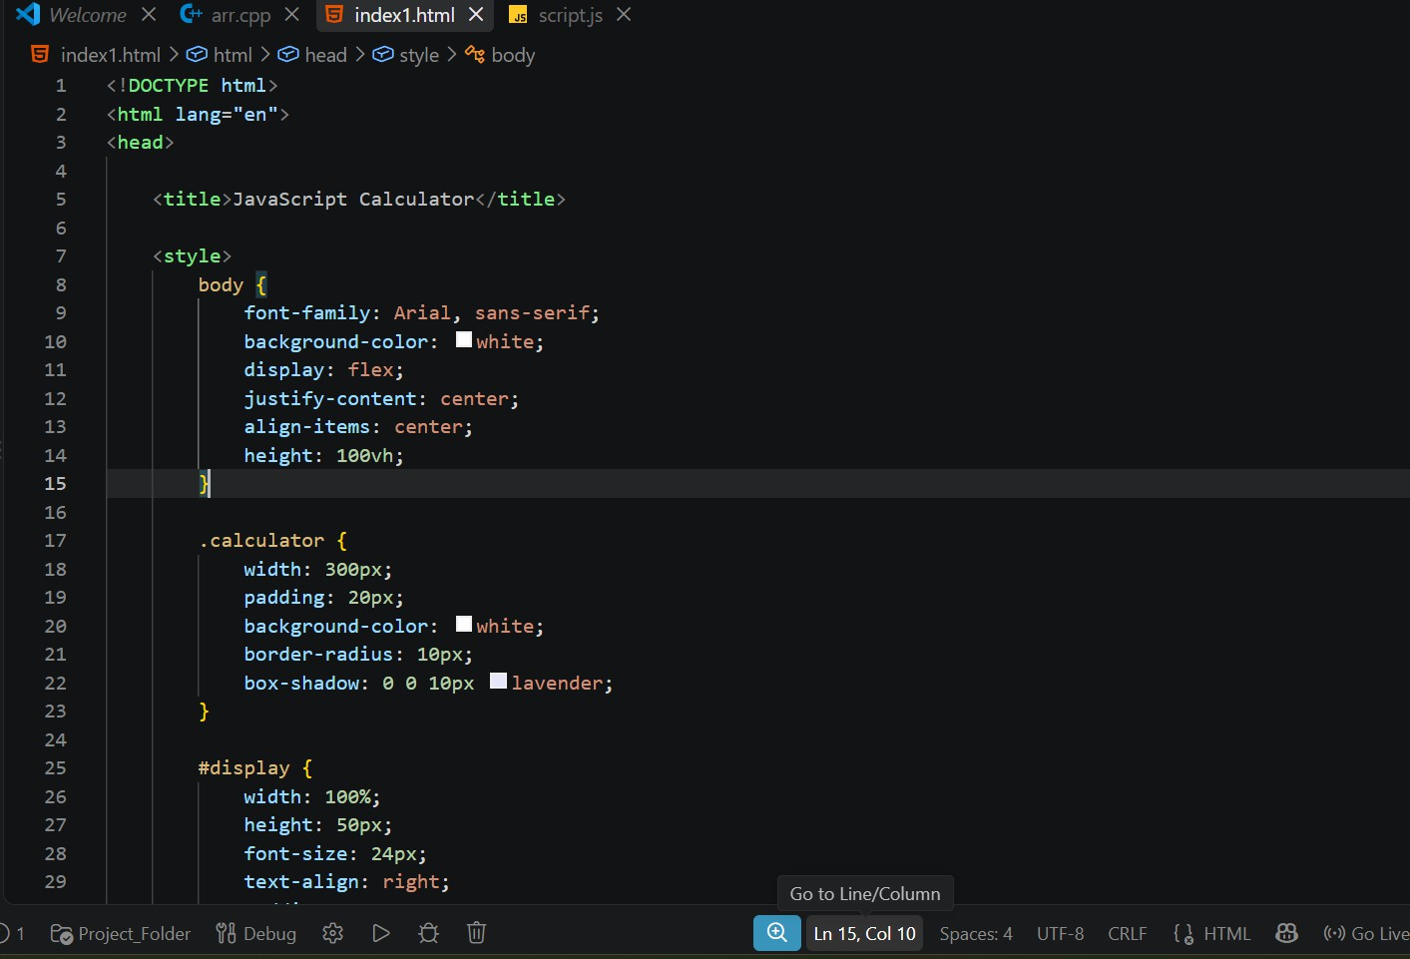

NAAC A++
Ph.: 07104-237919, 234623, 329249, 329250 Fax: 07104-232376, Website: www.ycce.edu

Department of Computer Technology
Vision Statement of the Department.
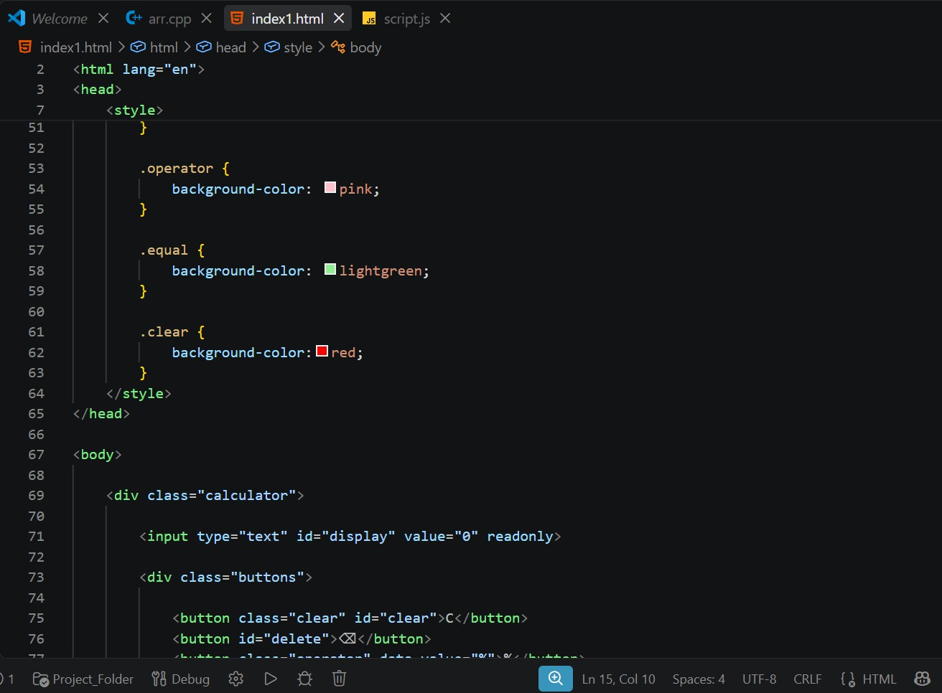

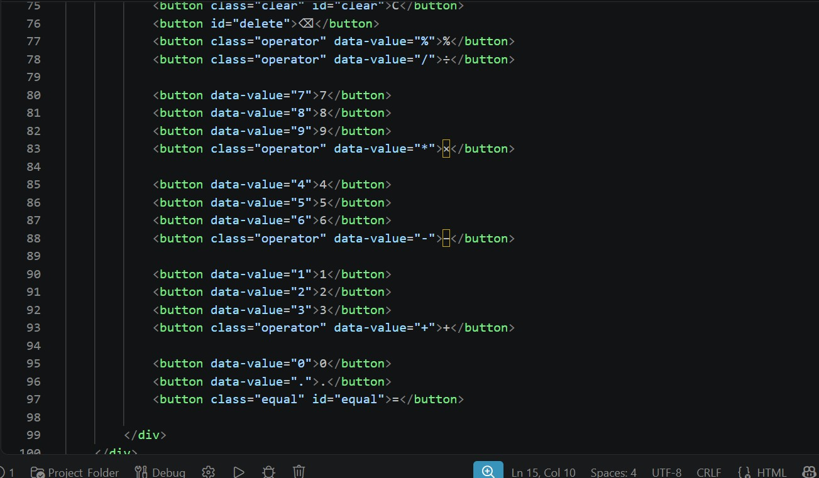

NAAC A++
Ph.: 07104-237919, 234623, 329249, 329250 Fax: 07104-232376, Website: www.ycce.edu

Department of Computer Technology
Vision Statement of the Department.
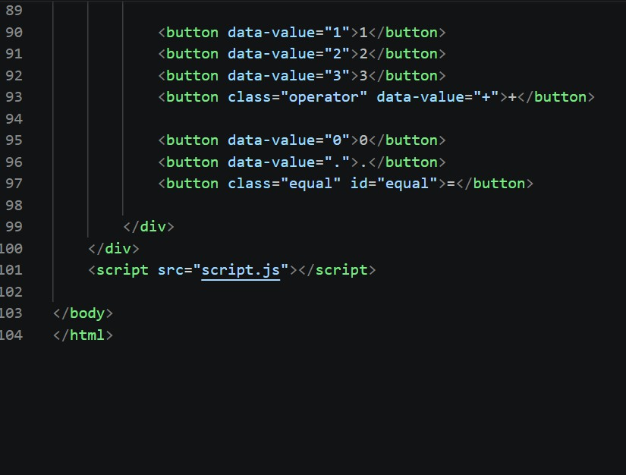

NAAC A++
Ph.: 07104-237919, 234623, 329249, 329250 Fax: 07104-232376, Website: www.ycce.edu

Department of Computer Technology
Vision Statement of the Department.
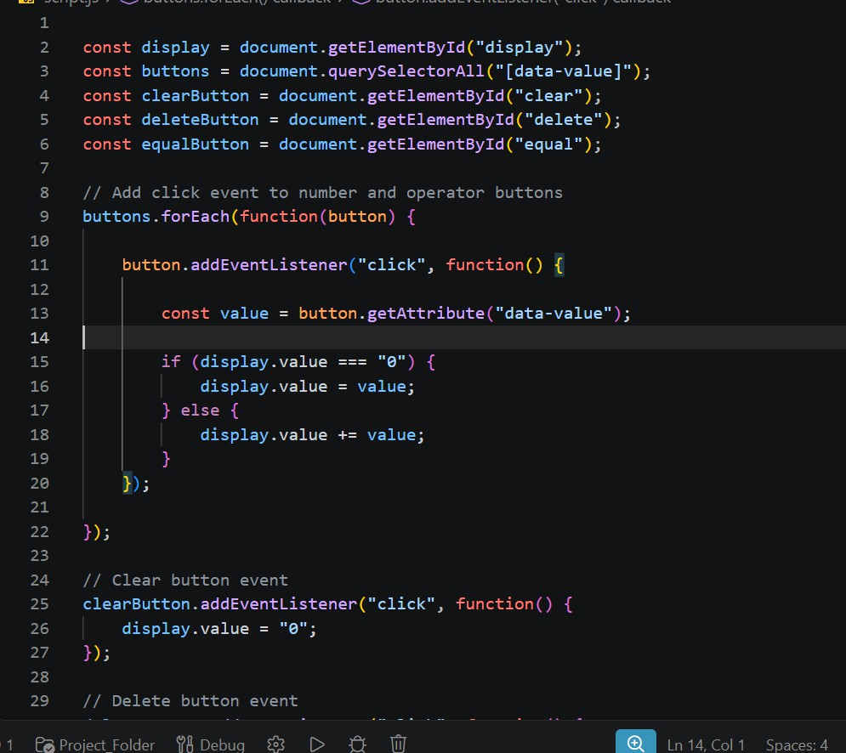

NAAC A++
Ph.: 07104-237919, 234623, 329249, 329250 Fax: 07104-232376, Website: www.ycce.edu

Department of Computer Technology
Vision Statement of the Department.
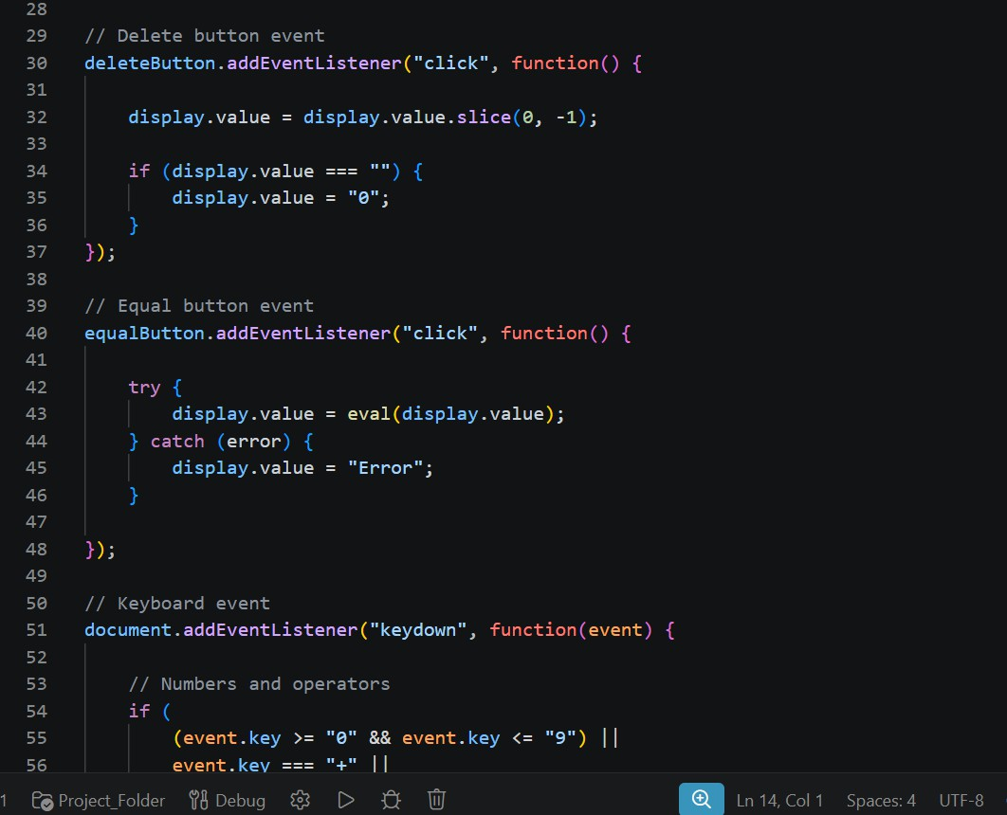

NAAC A++
Ph.: 07104-237919, 234623, 329249, 329250 Fax: 07104-232376, Website: www.ycce.edu

Department of Computer Technology
Vision Statement of the Department.
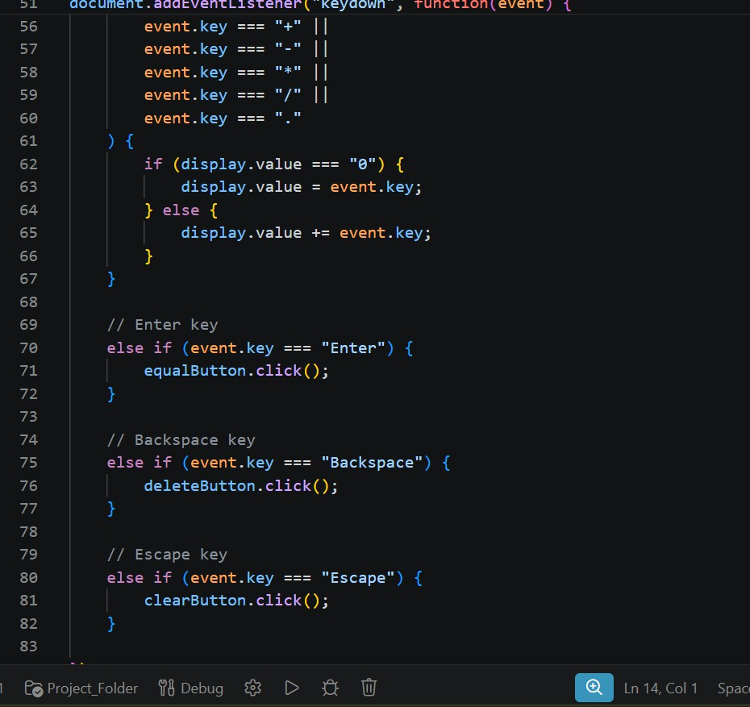

NAAC A++
Ph.: 07104-237919, 234623, 329249, 329250 Fax: 07104-232376, Website: www.ycce.edu

Department of Computer Technology
Vision Statement of the Department.
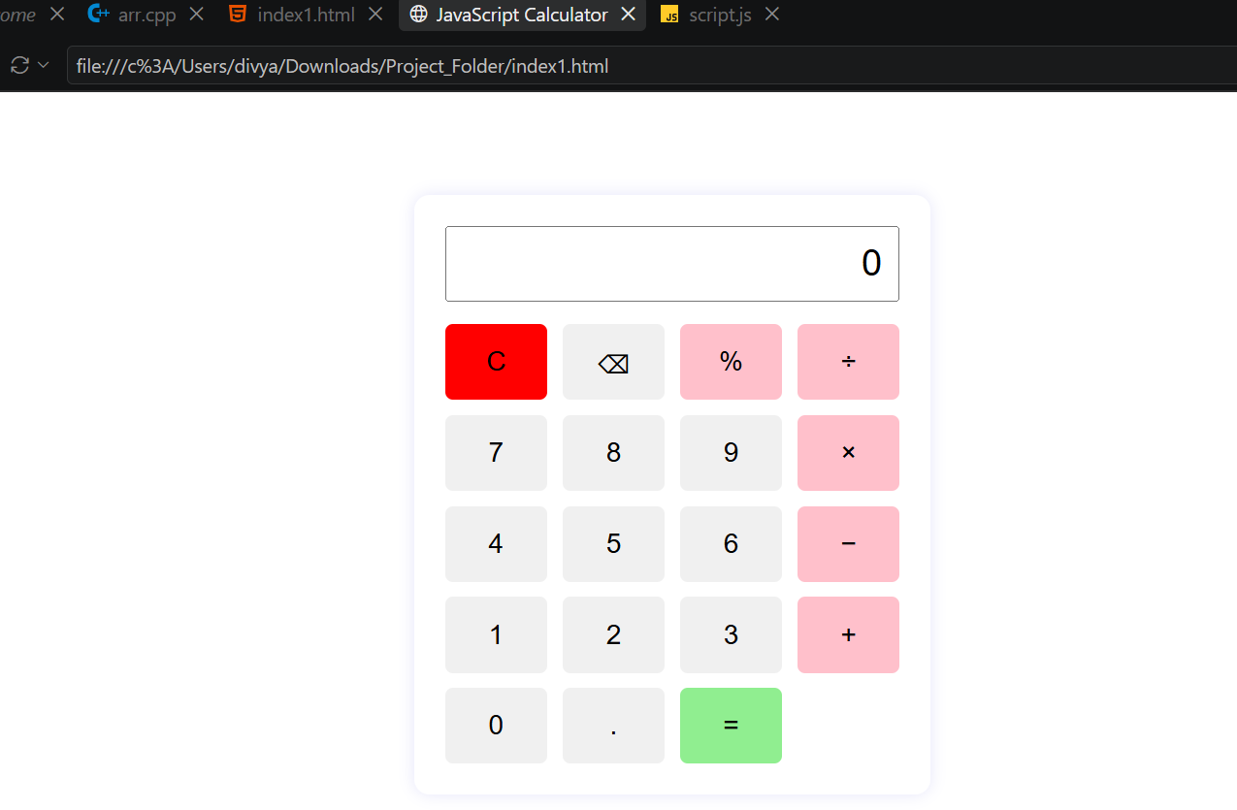
Output:
Output Analysis | The calculator successfully responds to button clicks and keyboard inputs. Users can enter numbers, select arithmetic operators, and obtain results dynamically. The display updates immediately according to user actions. The application demonstrates effective use of JavaScript events, DOM manipulation, and arithmetic operations.
Link of student Github profile  where lab assignment has been  uploaded | https://github.com/aratilod/Web-Technology-Practicals
Conclusion | The Calculator application demonstrates how JavaScript event handling and interactivity can be used to create dynamic web applications. By handling click and keyboard events and updating the DOM, the calculator provides an interactive user interface while strengthening understanding of JavaScript events and user-driven actions.
Plag Report (Similarity index < 12%) | 21-09-2026

NAAC A++
Ph.: 07104-237919, 234623, 329249, 329250 Fax: 07104-232376, Website: www.ycce.edu

Department of Computer Technology
Vision Statement of the Department.
Date | 21-09-2026

